**Name: KAMCHE YANN ARNAUD**

**Matricule : FE21A208**

**Department: Computer Engineering**

**Level: 300**

**Task: Implement a stack using Linked List**

1. **CODE**

/* Implementation of a Stack using Link List

Author: Kamche Yann Arnaud

Date: 12/05/2022

*/

#include<stdio.h>

#include<stdlib.h>

#include<conio.h>

struct Node{

int data;

struct Node* link;

};

struct Node* top = NULL;

//Empty Stack

void stackEmpty()

{

if (top == NULL)

printf("Stack: Empty");

return;

}

//Push operations inserts a node in the stack from the beginning

void Push(int x){

struct Node* temp = (struct Node*)malloc(sizeof(struct Node*));

temp->data = x;

temp->link = top;

top = temp;

}

//Pop operaion deletes the first node

void Pop(){

struct Node *temp;

if(top == NULL){

stackEmpty();

return;

}

else{

temp = top;

top = top->link;

free(temp);

return;

}

}

// displays the stack to the user

void Display(){

struct Node* temp;

temp = top;

printf("top-> ");

while (temp != NULL){

printf("%d ->", temp->data);

temp = temp->link;

}

printf("NULL");

return;

}

//sizeOfStack returns the number of nodes in the stack

int sizeOfStack(){

int count = 0;

struct Node* temp;

temp = top;

while(temp != NULL){

count++;

temp = temp->link;

}

return count;

}

//topOfStack returns the value at the top of the stack

int topOfStack(){

if(top == NULL)

return -1;

else

return top->data;

}

int main(){

system("color 2");

int choice, num, Top;

options:

printf("\n1. Push\n");

printf("2. Pop\n");

printf("3. Display Element at the Top of your list\n");

printf("4. Display your list\n");

printf("5. Size of stack\n");

printf("\nChoose the operation to be performed on your list: ");

scanf("%d", &choice);

switch(choice){

case 1:

printf("Enter a value: ");

scanf("%d", &num);

Push(num);

break;

case 2:

Pop();

break;

case 3:

Top = topOfStack();

if (Top == -1)

printf("Top: NULL");

else

printf("Top: %d", Top);

break;

case 4:

Display();

break;

case 5:

printf("Nodes: %d", sizeOfStack);

break;

default:

break;

}

goto options;

return 0;

}

1. **COMPILATION RESULTS**
2. **PUSH OPERATION**

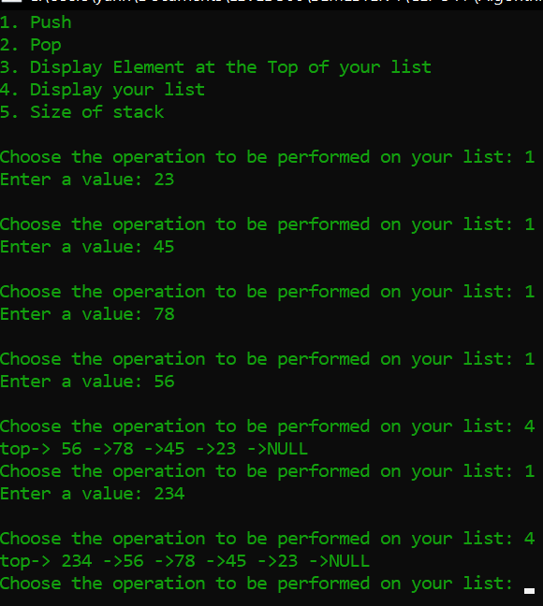

1. **POP OPERATION**

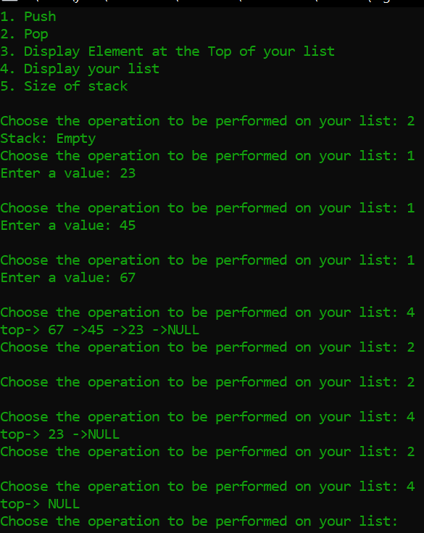

1. **Size of stack**

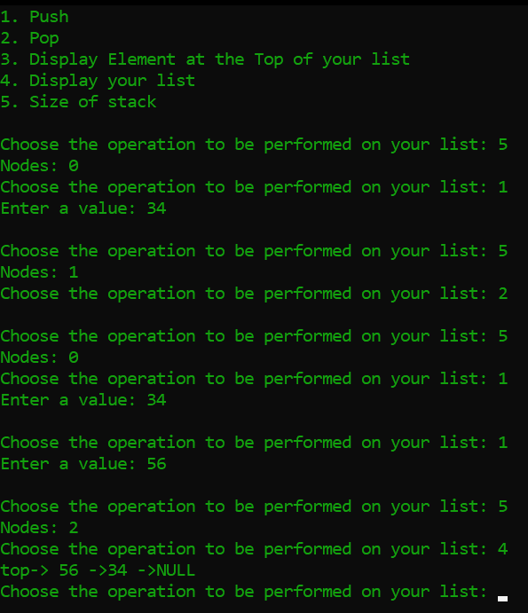

1. **Top of stack**

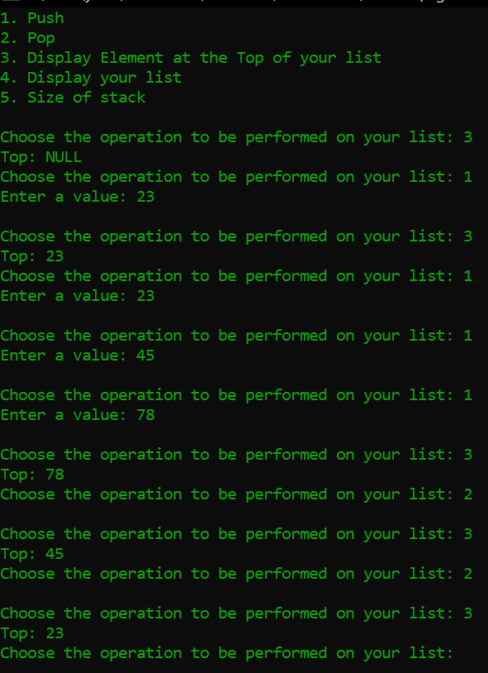

1. **Display stack**

